Title | Interactive Scatter Plot with Plotly
Problem Statement | Create an interactive scatter plot showing the relationship between house size and price.
Objectives | • To understand interactive scatter plot visualization using Plotly.  • To organize house size and house price data using a Pandas DataFrame.  • To visualize and interpret the relationship between house size and house price.  • To compute descriptive measures such as minimum, maximum, average, and correlation.  • To create a trendline for the relationship and save the interactive chart and dataset for further use.
Dataset  URL Link /  File | 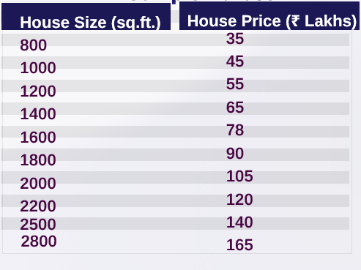  Dataset source: Manually defined in the Jupyter Notebook using the house-size and house-price values shown above; no external dataset URL is required.
Functions  Details | Sl. No. | Function | Package | Description of function
 | 1 | pd.DataFrame() | pandas | Creates a structured DataFrame from the house size and price data.
 | 2 | px.scatter() | plotly.express | Creates an interactive scatter plot from the DataFrame.
 | 3 | update_traces() | plotly | Updates marker size and text-position properties of the plotted points.
 | 4 | update_layout() | plotly | Updates the chart layout and axis titles.
 | 5 | show() | plotly | Displays the interactive Plotly chart inside the Jupyter Notebook.
 | 6 | sort_values() | pandas | Sorts the dataset based on house size in ascending order.
 | 7 | idxmax() | pandas | Returns the index of the record with the maximum house price.
 | 8 | idxmin() | pandas | Returns the index of the record with the minimum house price.
 | 9 | mean() | pandas | Calculates the average house price and average house size.
 | 10 | corr() | pandas | Calculates the correlation between house size and house price.
 | 11 | write_html() | plotly | Saves the interactive Plotly scatter plot as an HTML file.
 | 12 | to_csv() | pandas | Saves the house-price DataFrame as a CSV file without the index column.
Steps/  Process/  Procedure/  Algorithm/  Flowchart/  Model | 1. Import Pandas and Plotly Express for tabular data handling and interactive visualization.  2. Create a dictionary containing house sizes in square feet and corresponding house prices in lakhs.  3. Convert the dictionary into a Pandas DataFrame and display all ten records.  4. Verify the dataset shape and print the complete house-size and house-price lists.  5. Create a basic interactive scatter plot with house size on the X-axis and house price on the Y-axis.  6. Create an improved scatter plot with larger markers, value labels, title, and proper axis labels.  7. Sort the DataFrame by house size in ascending order and display the sorted dataset.  8. Use idxmax() and idxmin() to identify the most expensive and least expensive houses.  9. Calculate the average house price and average house size using mean().  10. Calculate the correlation between house size and price using corr() to measure the strength of their relationship.  11. Create a scatter plot with an OLS trendline to visually represent the positive relationship between size and price.  12. Display the final house-price analysis and save the interactive chart as HTML and the dataset as CSV.  Flow: START → Import Libraries → Create Dataset → DataFrame → Verify Data → Scatter Plot → Enhanced Plot → Sort Data → Price Statistics → Average Values → Correlation → Trendline → Save HTML/CSV → STOP
Program | import pandas as pd  import plotly.express as px  data = {  "House Size (sq.ft.)": [  800,  1000,  1200,  1400,  1600,  1800,  2000,  2200,  2500,  2800  ],  "House Price (Lakhs)": [  35,  45,  55,  65,  78,  90,  105,  120,  140,  165  ]  }  df = pd.DataFrame(data)  df  print("Dataset Shape:", df.shape)  print("\nHouse Sizes:")  print(df["House Size (sq.ft.)"].tolist())  print("\nHouse Prices:")  print(df["House Price (Lakhs)"].tolist())  fig = px.scatter(  df,  x="House Size (sq.ft.)",  y="House Price (Lakhs)",  title="House Size vs House Price"  )  fig.show()  fig = px.scatter(  df,  x="House Size (sq.ft.)",  y="House Price (Lakhs)",  title="Relationship Between House Size and Price",  text="House Price (Lakhs)"  )  fig.update_traces(  marker=dict(size=12),  textposition="top center"  )  fig.update_layout(  xaxis_title="House Size (sq.ft.)",  yaxis_title="House Price (Lakhs)"  )  fig.show()  sorted_df = df.sort_values(  by="House Size (sq.ft.)",  ascending=True  )  sorted_df  highest = df.loc[  df["House Price (Lakhs)"].idxmax()  ]  print("Most Expensive House:")  print(highest)  lowest = df.loc[  df["House Price (Lakhs)"].idxmin()  ]  print(  "Least Expensive House:",  lowest["House Size (sq.ft.)"],  "sq.ft. - ",  lowest["House Price (Lakhs)"],  "Lakhs"  )  average_price = df["House Price (Lakhs)"].mean()  print(  "Average House Price:",  round(average_price, 2),  "Lakhs"  )  average_size = df["House Size (sq.ft.)"].mean()  print(  "Average House Size:",  round(average_size, 2),  "sq.ft."  )  correlation = df[  "House Size (sq.ft.)"  ].corr(  df["House Price (Lakhs)"]  )  print(  "Correlation between House Size and Price:",  round(correlation, 3)  )  fig = px.scatter(  df,  x="House Size (sq.ft.)",  y="House Price (Lakhs)",  title="House Size vs Price with Trendline",  trendline="ols"  )  fig.update_traces(  marker=dict(size=12)  )  fig.update_layout(  xaxis_title="House Size (sq.ft.)",  yaxis_title="House Price (Lakhs)"  )  fig.show()  print("HOUSE PRICE ANALYSIS")  print("-" * 40)  print("Total Houses:", len(df))  print(  "Smallest House:",  df["House Size (sq.ft.)"].min(),  "sq.ft."  )  print(  "Largest House:",  df["House Size (sq.ft.)"].max(),  "sq.ft."  )  print(  "Lowest Price: ",  df["House Price (Lakhs)"].min(),  "Lakhs"  )  print(  "Highest Price: ",  df["House Price (Lakhs)"].max(),  "Lakhs"  )  print(  "Average Price: ",  round(df["House Price (Lakhs)"].mean(), 2),  "Lakhs"  )  print(  "Correlation:",  round(correlation, 3)  )  fig.write_html(  "house_size_price_scatter.html"  )  print("Interactive scatter plot saved successfully.")  df.to_csv(  "house_price_data.csv",  index=False  )  print("Dataset saved successfully.")
Output Snapshots  With  Explanation/  Observations | The following snapshots are taken from the completed Jupyter Notebook. The images retain the complete visible code/output blocks from each source page; only unused white margins were removed so no program output is cut off.  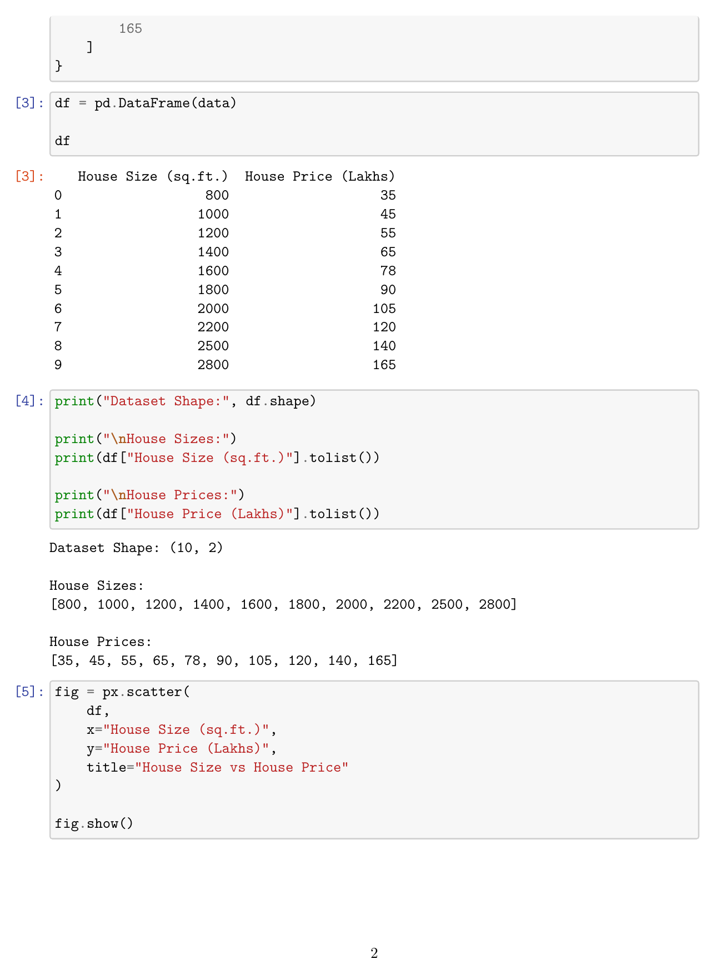  Fig. 1.1: DataFrame Creation, Dataset Verification, and Basic Scatter Plot Code  Explanation/Observation: The dataset is converted into a Pandas DataFrame with 10 rows and 2 columns. The complete house-size and house-price lists are verified, and the code for the initial interactive scatter plot is executed.  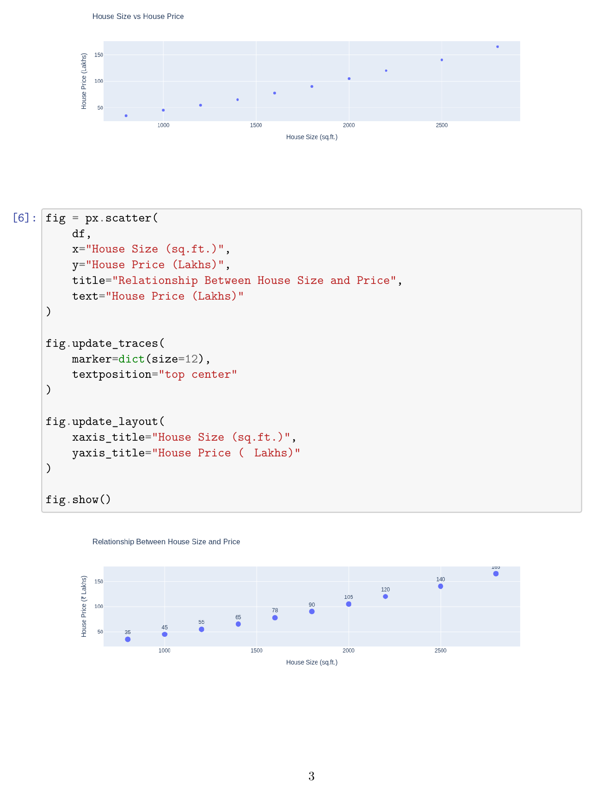  Fig. 1.2: Interactive and Enhanced Scatter Plots  Explanation/Observation: The first scatter plot shows house size versus price. The enhanced Plotly chart adds larger markers and price labels, making the strong upward relationship between size and price visually clear.  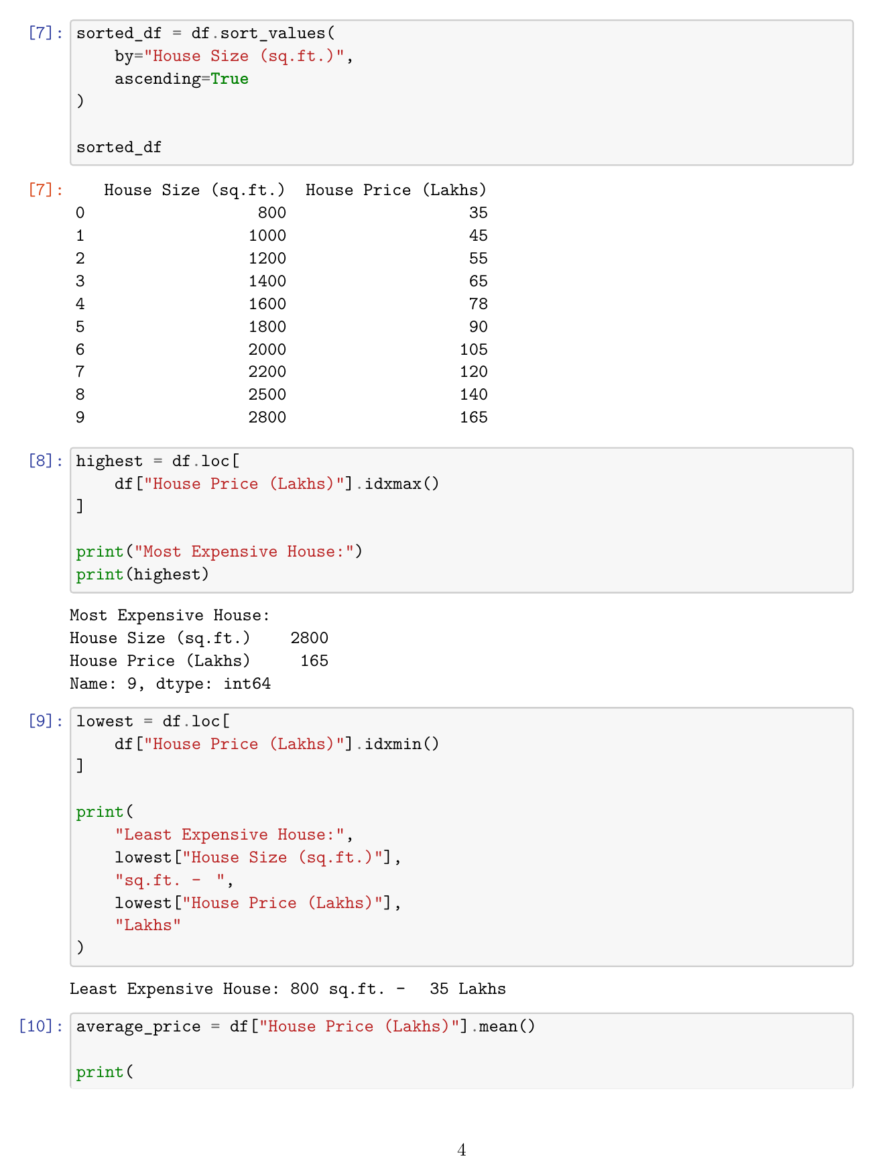  Fig. 1.3: Sorted Dataset and Extreme Price Analysis  Explanation/Observation: The dataset is sorted by house size in ascending order. The program identifies the 2800 sq.ft. house priced at 165 lakhs as the most expensive and the 800 sq.ft. house priced at 35 lakhs as the least expensive.  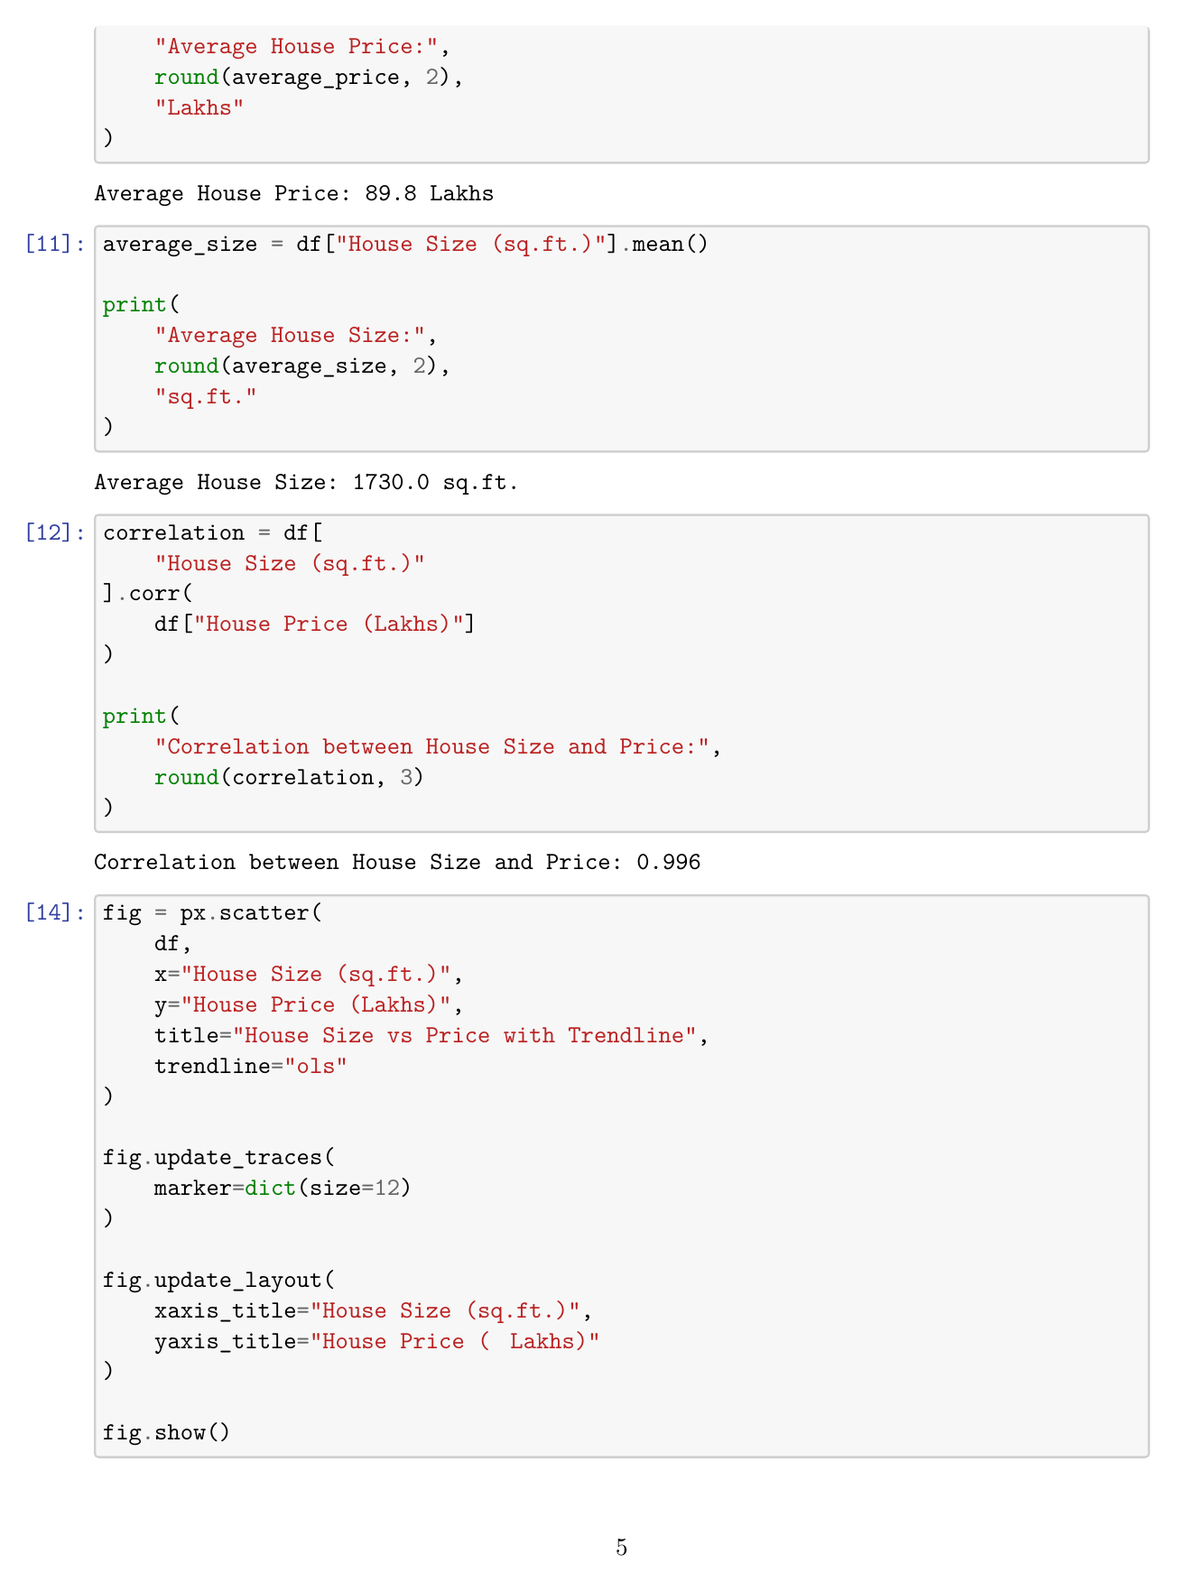  Fig. 1.4: Average Values, Correlation, and Trendline Program  Explanation/Observation: The average house price is 89.8 lakhs and the average house size is 1730 sq.ft. The calculated correlation is 0.996, indicating a very strong positive relationship. The trendline scatter-plot code is also shown.  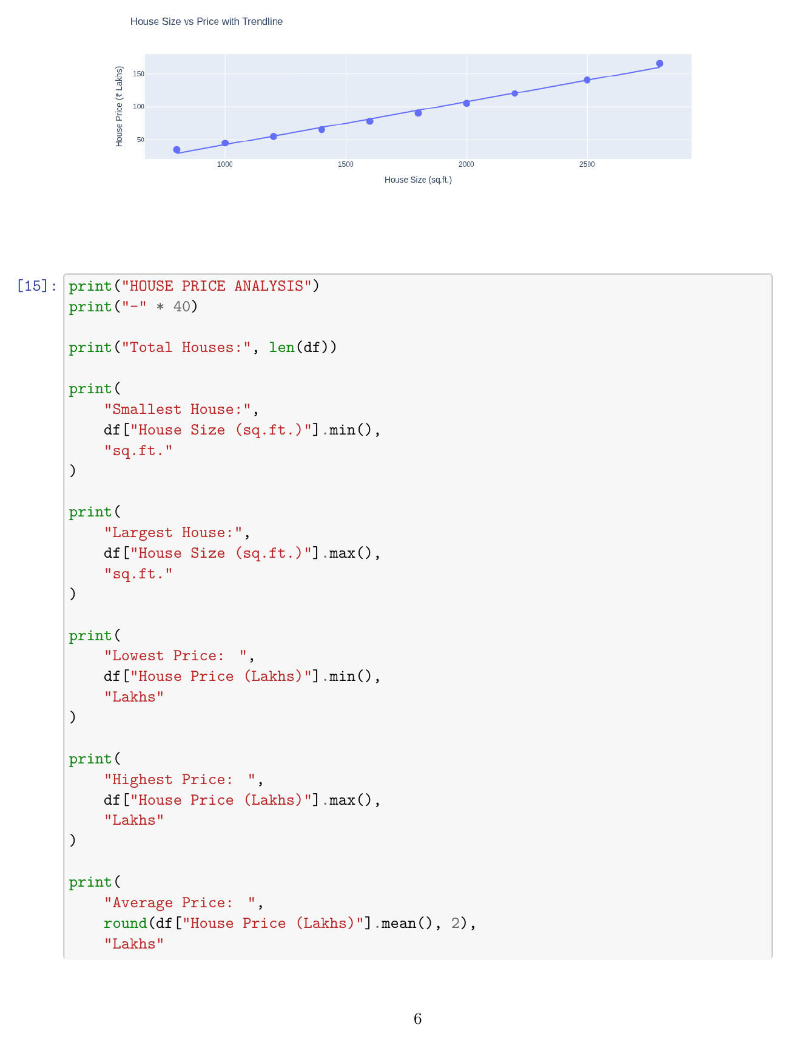  Fig. 1.5: Scatter Plot with OLS Trendline and Final Analysis Code  Explanation/Observation: The Plotly scatter plot with an OLS trendline confirms that house price rises strongly with house size. The final analysis code computes the smallest/largest houses and lowest/highest/average prices.  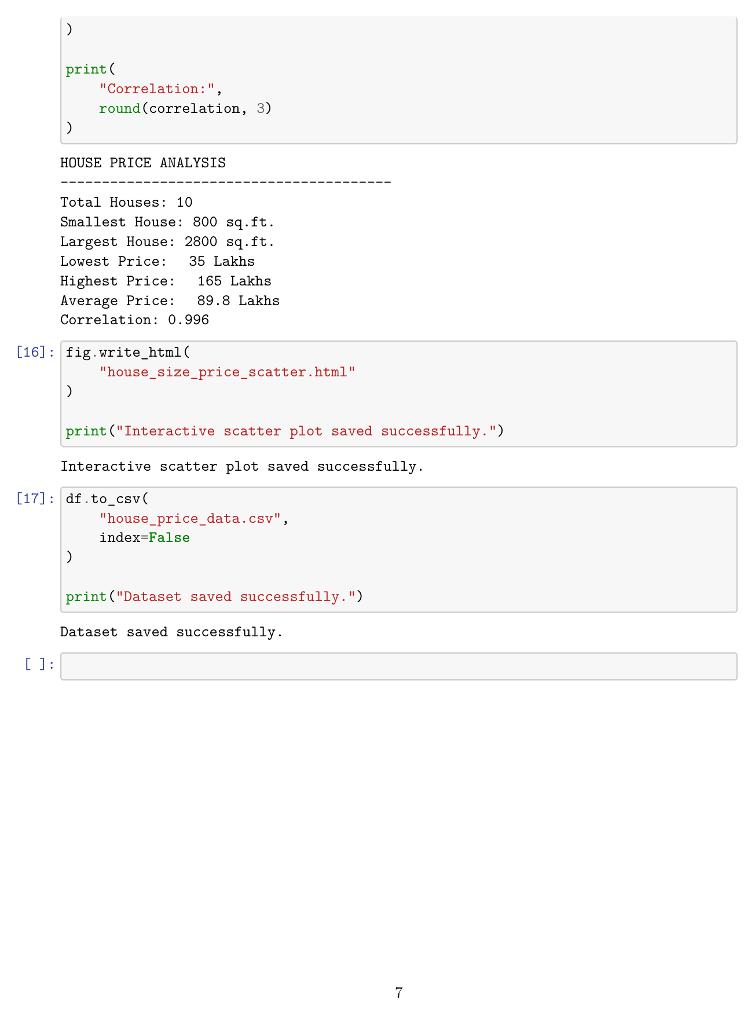  Fig. 1.6: Final House Price Analysis and File Saving Output  Explanation/Observation: The final output confirms 10 houses, sizes from 800 to 2800 sq.ft., prices from 35 to 165 lakhs, an average price of 89.8 lakhs, and correlation of 0.996. The interactive HTML chart and CSV dataset are saved successfully.
Conclusions | The experiment was successfully completed using Pandas and Plotly. House size and price data were organized in a Pandas DataFrame and visualized through interactive scatter plots. The analysis found an average house size of 1730 sq.ft., an average price of 89.8 lakhs, and a correlation of 0.996, showing a very strong positive relationship between house size and price. An OLS trendline further confirmed this relationship. The interactive chart and dataset were successfully saved as HTML and CSV files.
References | 1. Michael Freeman and Joel Ross, Programming Skills for Data Science: Start Writing Code to Wrangle, Analyze, and Visualize Data with R, Addison-Wesley, 2018.  2. Python Program (GitHub link):  3. Class lecture link: Open Lecture File

